South Brisbane Men’s Shed Inc.

President’s Report March 2018

What a sensational month for our shed with our membership now reaching 60 and the shed open four days a week. Here are some examples of our activities this past month.

# Another successful Sausage sizzle at Bunnings. We raised around $700 towards our funding goals
# Attended Bunnings Easter family night with music and other activities (thank you Brian and Ray)
# Conducted an amazing neighbour day event with SWARA, SPELD, autism hub, Rotary and The Brisbane City Council (thanks to all members who contributed to this event)
# Completed several wood work projects (Mater Hospital, Gabba Hill Community Garden)
# Conducted our first Shed Presentation on Cardiopulmonary Resuscitation (CPR)
# SBMS Has been awarded $20k grant from the gambling benefit fund. This will be used to renovate the heritage shed

Upcoming Special events:
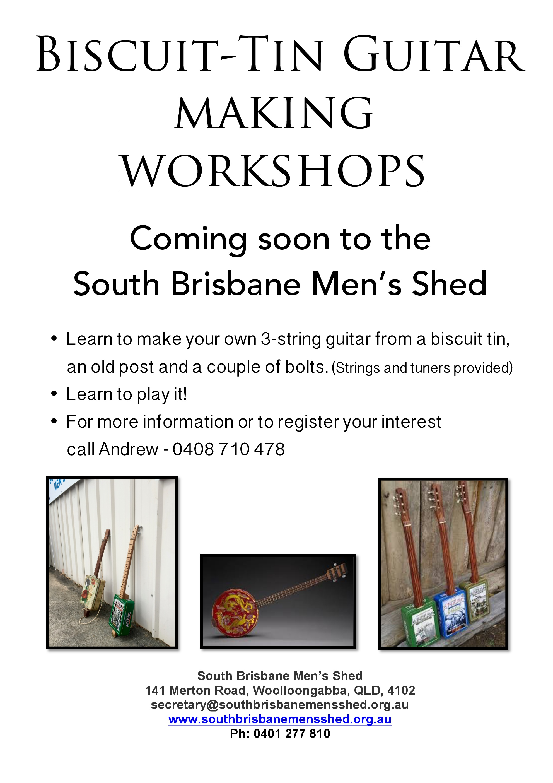.
Please contact Andrew at the shed or apply to Seretary@southbrisbanemensshed.org.au

Leatherwork Classes

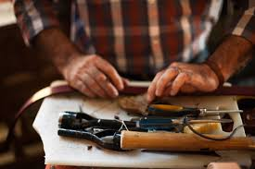

We are seeking expressions pf interest to join a leatherwork class meeting at the shed every Wednesday morning. Please talk to Ted or Graham at the shed or email Seretary@southbrisbanemensshed.org.au

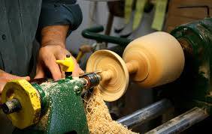

Our Friends from Shed West will be visiting Monday 30th April commencing 9am and will demonstrate wood turning. We will also hold a sausage sizzle lunch that day.

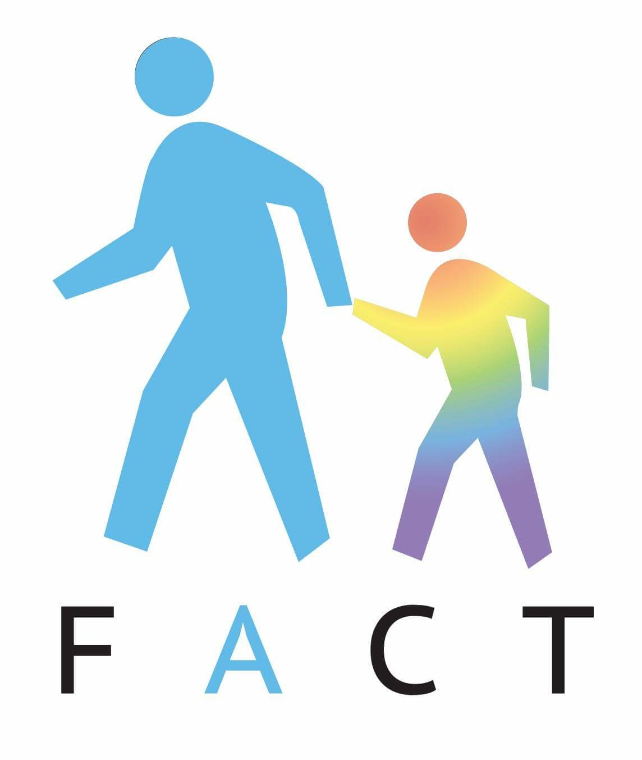Our fathers group will be holding a BBQ and A in April and this event will be part of autism month

Look out for our Involvement in Autism Month

April 29th Kurilpa Point Park South Brisbane 9AM – 11-30 Am

Trust we will see you in the Shed soon

David Spillane
President
South Brisbane Men’s shed Inc.

